2021 Paper

Q1

1. Calculate $$A^{T}A$$ (as row<col) get $$\left[\left[17 8\right]\left[8 17\right]\right]$$
2. $$\left(25−λ\right)\left(9−λ\right)=0$$ so $$λ_{1}=25 →σ_{1}=5$$ and $$λ_{2}=9 →σ_{1}=3$$
3. Find eigenspace for each:
$$λ_{1}=25 → \left\{{\left[1,1\right]}^{T}\right\}→v_{1}=\frac{1}{\sqrt{2}}{\left[1,1\right]}^{T}$$

$$λ_{2}=9 → \left\{{\left[1,−1\right]}^{T}\right\}→v_{2}=\frac{1}{\sqrt{2}}{\left[1,−1\right]}^{T}$$

4. Construct $$V=\left\{v_{1}, v_{2}\right\}$$
5. For

Q2

1. (from revision session)

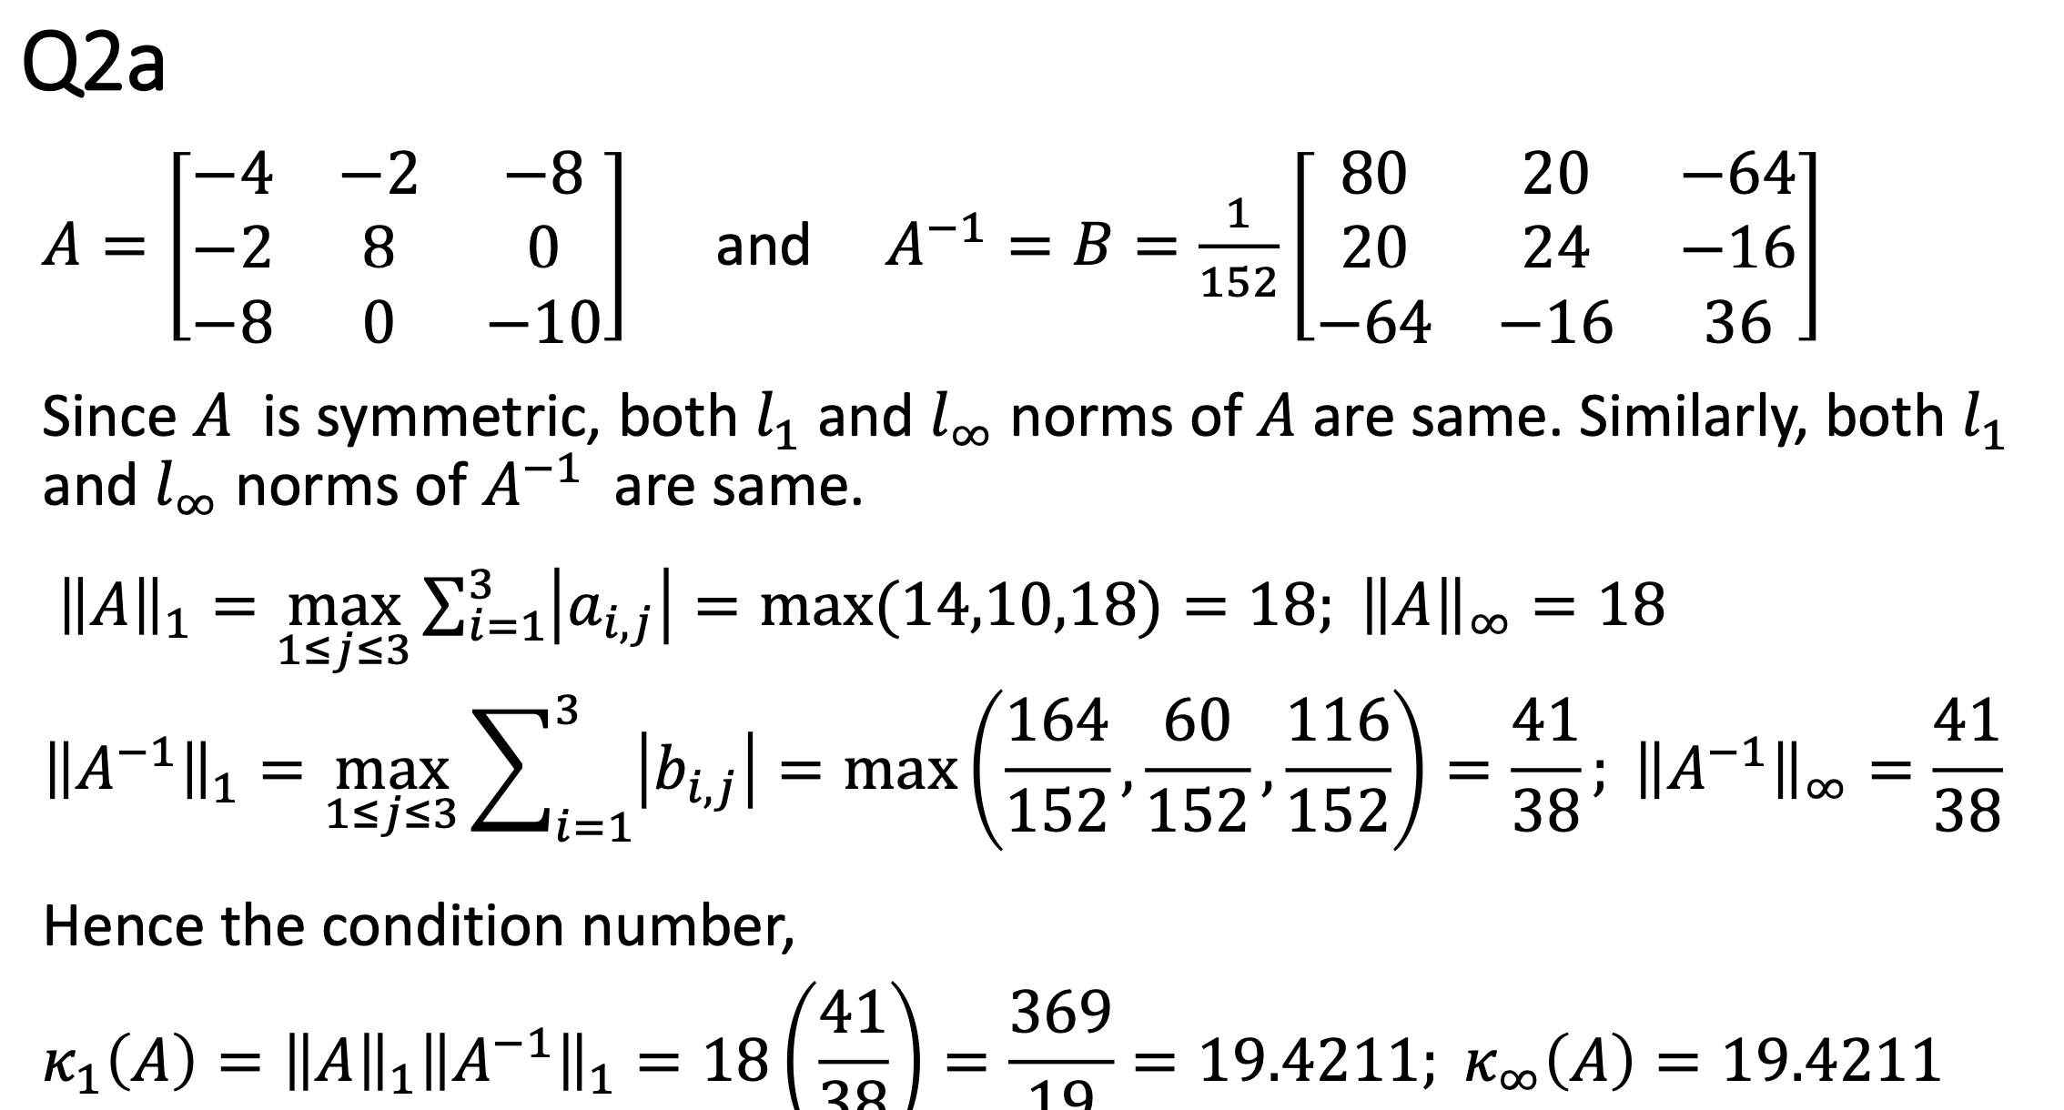

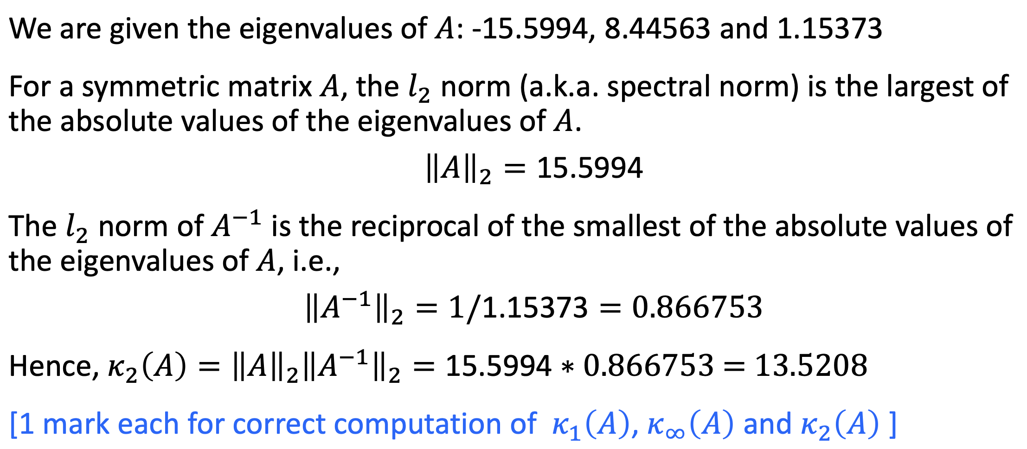

2b)I) (idk)

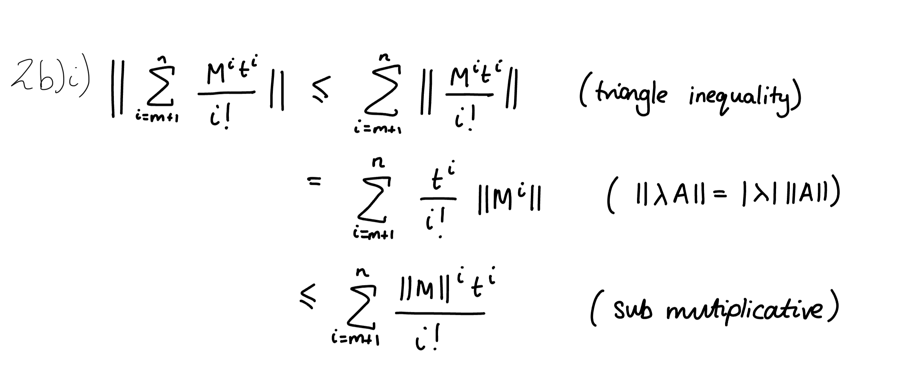

2bii)